Hello DGF-
Get ready for a Week of Wellness
sponsored by DGF Wellness!
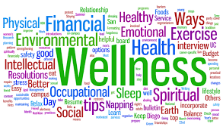

DGF’s Week of Wellness (Jan. 8-16)

January 8-Did you know? The smell of an orange relieves stress. Smelling an orange or eating one can reduce stress by over 70%.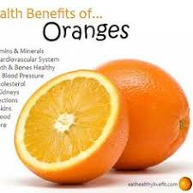

Go to a DGF lounge, find an orange, and eat it! Smile : )

January 9-Go get your mail! Collect the Dove Dark Chocolate in your mailbox. : ) 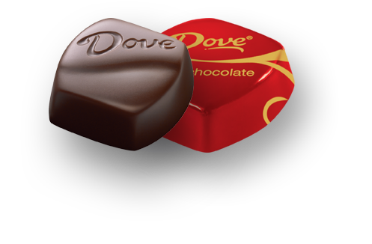

January 10-Share a good educational/enjoyable/motivational "must read" with another staff member. Go to your mailbox
and/or lounge. Pick up a form. Fill it out. Give it to a colleague. : )

“Whenever you read a good book, somewhere in the world a door opens to allow in more light.”
–Vera Nazarian
Who can’t use a little more light. Start writing. Start reading! : )

January 11-Look for a healthy surprise in your mailbox and/or lounges.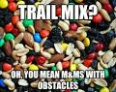

HOW TO BUILD A HEALTHY TRAIL MIX

1. Nuts – Feel free to use any kind of nut here! Ideally, purchase raw nuts that haven’t been coated and roasted in hydrogenated or soybean oils and salt. You’re welcome to dry roast them at home for an added toastiness, but if you’re a nut purist, just keep them raw.
2. Seeds – Don’t forget about seeds! Often overlooked for the health benefits of nuts, seeds actually pack a serious nutritional punch including protein, iron, magnesium and an array of vitamins and minerals. Again, look for raw, unsalted seeds.
3. Dried Fruit – Because of the high sugar content in dried fruit, they’re a great snack to help boost your low blood sugar after a high dose of physical activity. Be careful when picking dried fruit! Do your best to find sun dried fruit that isn’t coated in sugar and is ideally unsulfured. It’s more expensive, but it’s worth it.
4. Fun Stuff!– Just because it’s healthy doesn’t mean you can’t throw in a little fun! I’m all about balance, so feel free to add in a handful of your favourite decadent or healthified decadent treat. Dark chocolate and popcorn are my favs so those are my go-tos but feel free to get a little crazy with some pretzels, peanut butter chips or other sweet treat.

January 12-Share your gratitude with others. We don’t care what language you use; just say “thank you!” Look for the forms in your mailbox and/or lounges!

“We must find time to stop and thank the people who make a difference in our lives.”
― John F. Kennedy

We work with some pretty awesome people! Start writing! : )

January 15/16-Drink EXTRA water today! Go find some water in the lounges. It’s there.

“Your brain consists of 90% water so drinking more can improve your productivity at work and in doing other tasks. It helps you think better, be more alert, and helps make you concentrate a lot better.”-Eat Clean/Live Healthy

January 17+ You are on your own; however, we are confident you’ll be able to continue the weeks of wellness throughout January and beyond. You’re creative people. Start creating! : )
--DGF Wellness Committee

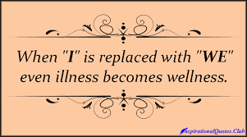

PS Get ready for DGF’s March Madness (March 5-March 30, 2018)

